7th Form National Poetry Recitation Contest

Title of Poem: The Little Boy and the Old Man
Poet: Shel Silverstein
Link: http://famouspoetsandpoems.com/poets/shel_silverstein/poems/14823

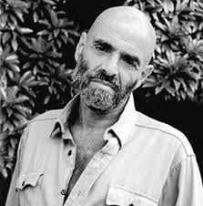

About the poet (From Wikipedia)
Shel Silverstein
Sheldon Allan "Shel" Silverstein was an American writer known for his cartoons, songs, and children's books. He styled himself as Uncle Shelby in some works. His books have been translated into more than 30 languages and have sold more than 20 million copies.

The Little Boy and the Old Man
By Shel Silverstein

Said the little boy, "Sometimes I drop my spoon."
Said the old man, "I do that too."
The little boy whispered, "I wet my pants."
"I do that too," laughed the little old man.
Said the little boy, "I often cry."
The old man nodded, "So do I."
"But worst of all," said the boy, "it seems
Grown-ups don't pay attention to me."
And he felt the warmth of a wrinkled old hand.
"I know what you mean," said the little old man.

Vocab:
Whisper – speak quietly, softly
Grown-ups – adults
Wrinkled – (can refer to clothes or skin) having slight folds

Post-Reading Questions:
Do you think the comparisons between the little boy and the little old man are true?
How do you feel after reading this poem? Sad or happy?
What are some new words you learned in this poem?

