8th Form National Poetry Recitation Contest

Title of Poem: Rain
Poet: Kazim Ali
Link: https://www.poetryfoundation.org/poems/54262/rain-56d23467ac47f

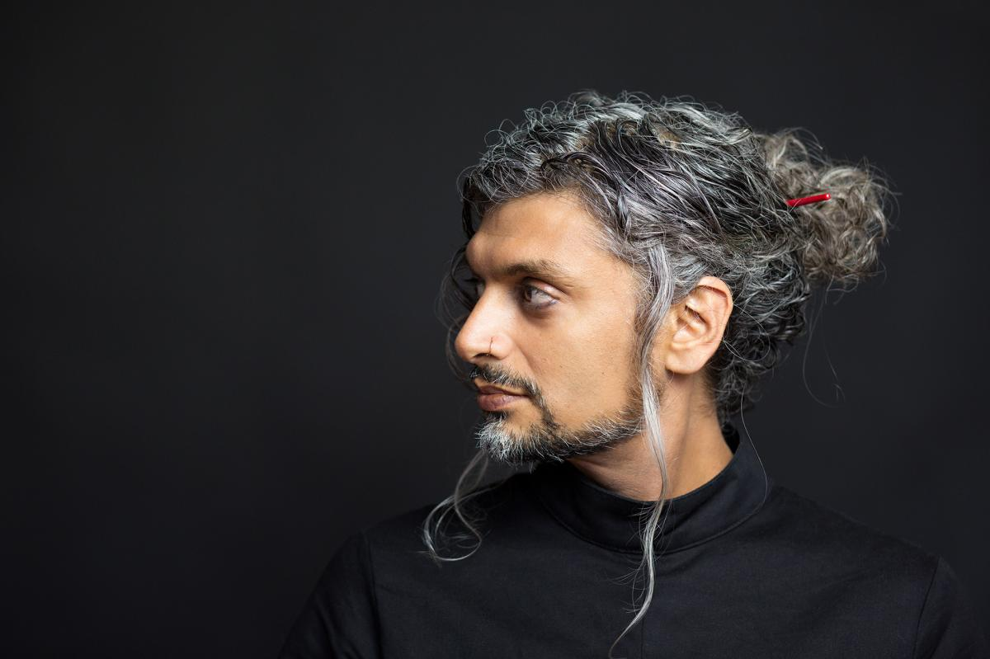

About the Poet (From Poetry Foundation):

Poet, editor, and prose writer Kazim Ali was born in the United Kingdom to Muslim parents of Indian descent. He received a BA and MA from the University of Albany-SUNY, and an MFA from New York University.

Ali’s poetry collections include The Far Mosque (2005), which won Alice James Books’ New England/New York Award, The Fortieth Day (2008), Sky Ward (2013), and Inquisition (2018). Ali’s poems, both lyric and musical, explore the intersection of faith and daily life. In a review of The Fortieth Day, Library Journal noted that Ali “continues his task of creating a rejuvenated language that longs to be liberated from the weight of daily routine and the power of dogmatic usage . . . writing in the tradition of Wallace Stevens, Ali is clearly a poet of ideas and symbols, yet his words remain living entities within the texture of the poem.”

Rain

By Kazim Ali
With thick strokes of ink the sky fills with rain.
Pretending to run for cover but secretly praying for more rain.

Over the echo of the water, I hear a voice saying my name.
No one in the city moves under the quick sightless rain.

The pages of my notebook soak, then curl. I’ve written:
“Yogis opened their mouths for hours to drink the rain.”

The sky is a bowl of dark water, rinsing your face.
The window trembles; liquid glass could shatter into rain.

I am a dark bowl, waiting to be filled.
If I open my mouth now, I could drown in the rain.

I hurry home as though someone is there waiting for me.
The night collapses into your skin. I am the rain.

Study Guide:

What does “Yogis” mean?

Why do you think the author compares himself with “a dark bowl”?

Vocab:

Strokes – a mark made by some sort of instrument

Curl – action of forming a curve or spiral

Sightless – without vision

