10th Form National Poetry Recitation Contest

Title of Poem: Ozymandias
Poet: Percy Bysshe Shelley
Link: https://www.poets.org/poetsorg/poem/ozymandias
Link to audio recording of the poem: https://www.poetryfoundation.org/podcasts/75866/ozymandias

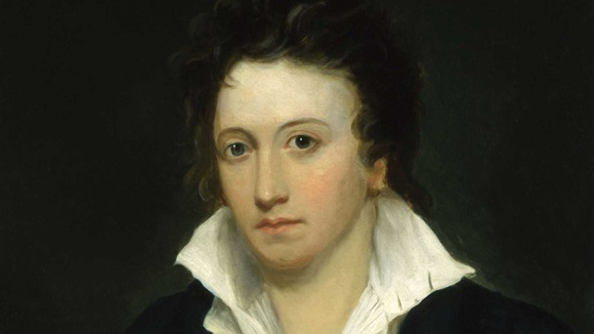

About the Poet: https://www.poets.org/poetsorg/poet/percy-bysshe-shelley
Percy Bysshe Shelley
Percy Bysshe Shelley was born August 4, 1792, near Sussex, England.
He attended both Eton College and Oxford University, and he began writing poetry while at Eton. He authored many pamphlets and essays, some of which were controversial at the time and resulted in his expulsion from Oxford. Percy continued to write short stories, longer narratives, and poems until his death in 1822 when his schooner was lost at sea.

Ozymandias
By Percy Bysshe Shelley

I met a traveller from an antique land
Who said: “Two vast and trunkless legs of stone
Stand in the desert . . . Near them, on the sand,
Half sunk, a shattered visage lies, whose frown,
And wrinkled lip, and sneer of cold command,
Tell that its sculptor well those passions read
Which yet survive, stamped on these lifeless things,
The hand that mocked them, and the heart that fed:
And on the pedestal these words appear:
‘My name is Ozymandias, king of kings:
Look on my works, ye Mighty, and despair!'
Nothing beside remains. Round the decay
Of that colossal wreck, boundless and bare
The lone and level sands stretch far away.”

About the Poem

This poem explores the effect time has on even the most accomplished and important men and empires. In it, the narrator meets with a traveler who tells him about a massive statue in the desert. The statues face is that of a great Egyptian ruler and the inscription states that it is “Ozymandias, King of Kings.” The statue is in ruins and nothing else remains, showing that even the greatest kings and all their works can be reduced to nothing by the movement of time

Useful Vocabulary

Antique: adjective – belonging to ancient times

Visage: A person’s face or facial expression

Pedestal: The stand upon which a statue is set

Despair: To lose or to be without hope

Discussion Guide:
Do you believe that every civilization will eventually come to an end?
Why do you think ancient kings believed they would be remembered forever?
Do you think that pride or hubris are bad traits to possess?
What is the oldest item you have ever seen? What did it make you think about the people who it belonged to?

