10th Form National Poetry Recitation Contest
Title of speech: “Me Too”
Writer: Oprah Winfrey, speaking at the Golden Globes 2018
Link to audio recording of the speech: https://www.youtube.com/watch?v=fN5HV79_8B8

Excerpt:
What I know for sure is that speaking your truth is the most powerful tool we all have. And I’m especially proud and inspired by all the women who have felt strong enough and empowered enough to speak up and share their personal stories. Each of us in this room are celebrated because of the stories that we tell. And this year we became the story. But it’s not just a story affecting the entertainment industry. It’s one that transcends any culture, geography, race, religion, politics or workplace.
So I want tonight to express gratitude to all the women who have endured years of abuse and assault, because they — like my mother — had children to feed and bills to pay and dreams to pursue. They’re the women whose names we’ll never know. They are domestic workers and farmworkers; they are working in factories and they work in restaurants, and they’re in academia and engineering and medicine and science; they’re part of the world of tech and politics and business; they’re our athletes in the Olympics and they’re our soldiers in the military…
So I want all the girls watching here and now to know that a new day is on the horizon! And when that new day finally dawns, it will be because of a lot of magnificent women, many of whom are right here in this room tonight, and some pretty phenomenal men, fighting hard to make sure that they become the leaders who take us to the time when nobody ever has to say, ‘Me too’ again. Thank you.”

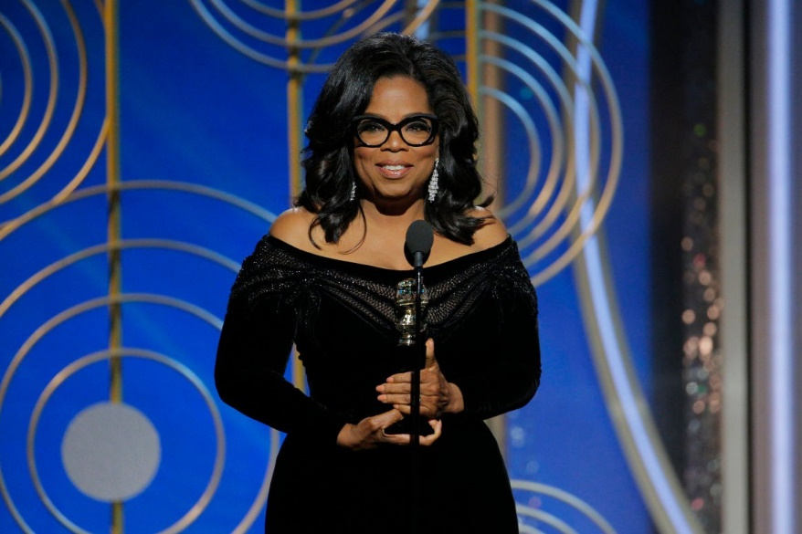
About the Speaker: Oprah Winfrey (born Orpah Gail Winfrey; January 29, 1954) is an American media executive, actress, talk show host, television producer and philanthropist. She is best known for her talk show The Oprah Winfrey Show, which was the highest-rated television program of its kind in history. Dubbed the "Queen of All Media", she was the richest African American of the 20th century and North America's first black multi-billionaire, and has been ranked the greatest black philanthropist in American history. She has also been sometimes ranked as the most influential woman in the world.
As a child, Oprah suffered sexual abuse. All her life she has campaigned for the rights of women and children, and for African Americans. The excerpt is from a speech at the Golden Globe entertainment awards where Oprah was honored with a special award—she was the first black woman to win this particular prize.

About the speech

In this speech Oprah Winfrey is referencing the scandal that hit Hollywood in 2018. Many actresses spoke publicly about assaults and harassment they had suffered from male movie executives. This became known as the “Me Too” movement. Oprah has spoken movingly about her own abuse before. She did not make this speech about her, but about all women, and the need to stand together—and with good men—to say that this treatment of any human being, man or woman is unacceptable and must not be allowed to happen.

Discussion Guide:
How do Oprah’s words make you feel? Do you think she is brave or cowardly? Boring or inspiring? Right or wrong?
Why do you think Oprah mentioned men in her speech? Did she talk about them in a negative or a positive way? Why?
What would you say to the women of Armenia if you were as famous here as Oprah Winfrey is in America?

