9th Form National Poetry Recitation Contest

Title of Poem: Jerusalem
Poet: William Blake
Link: https://www.poetryfoundation.org/poems/54684/jerusalem-and-did-those-feet-in-ancient-time

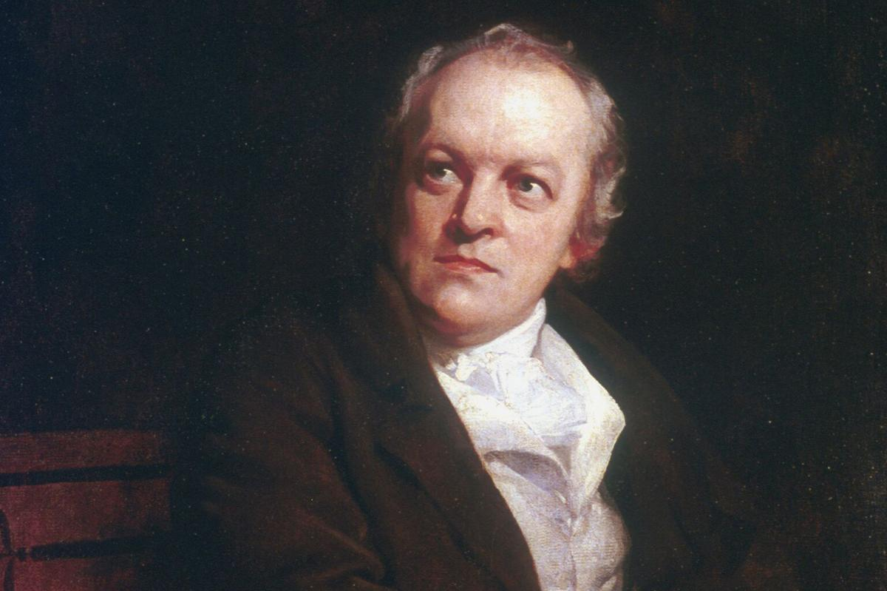
About the Poet (From Wikipedia):

William Blake (28 November 1757 – 12 August 1827) was an English poet, painter, and printmaker. Largely unrecognised during his lifetime, Blake is now considered a seminal figure in the history of the poetry and visual arts of the Romantic Age. What he called his prophetic works were said by 20th-century critic Northrop Frye to form "what is in proportion to its merits the least read body of poetry in the English language". His visual artistry led 21st-century critic Jonathan Jones to proclaim him "far and away the greatest artist Britain has ever produced". In 2002, Blake was placed at number 38 in the BBC's poll of the 100 Greatest Britons. While he lived in London his entire life, except for three years spent in Felpham, he produced a diverse and symbolically rich œuvre, which embraced the imagination as "the body of God" or "human existence itself".

Jerusalem
By William Blake

And did those feet in ancient time
Walk upon Englands mountains green:
And was the holy Lamb of God,
On Englands pleasant pastures seen!

And did the Countenance Divine,
Shine forth upon our clouded hills?
And was Jerusalem builded here,
Among these dark Satanic Mills?

Bring me my Bow of burning gold:
Bring me my arrows of desire:
Bring me my Spear: O clouds unfold!
Bring me my Chariot of fire!

I will not cease from Mental Fight,
Nor shall my sword sleep in my hand:
Till we have built Jerusalem,
In Englands green & pleasant Land.

Study Guide:

What is the “Holy Lamb of God”?

What do you think the author is trying to say in this poem?

Vocab:

Pastures – grasslands

Chariot – a ancient vehicle with 2 wheels and pulled by horses

Jerusalem – the ancient holy city in Israel

