8th Form National Poetry Recitation Contest:

Title of Poem: The Trees
Poet: Philip Larkin
Link: https://www.poetryarchive.org/poem/trees

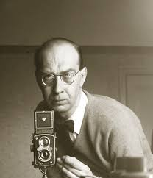

About the Poet: Philip Larkin was a notable British poet, known for his stylistic and dark poetry; his works often deal with sad subject matter such as death. He was often referred to as the poet of his generation. A quiet, unassuming man, he never married and worked in various libraries throughout his life.

The Trees
By Philip Larkin

The trees are coming into leaf
like something almost being said;
the recent buds relax and spread,
their greenness is a kind of grief.

Is it that they are born again
and we grow old? No, they die too,
their yearly trick of looking new
is written down in rings of grain.

Yet still the unresting castles thresh
in fullgrown thickness every May.
Last year is dead, they seem to say,
begin afresh, afresh, afresh.

About the Poem: This poem compares the lifespan and aging of a tree to that of a person. It first seems that the tree does not age, and is continually reborn and able to find its youth. However, on further investigation, one realizes that the tree ages as well. The tree’s aging can teach us about our own.

Discussion Guide:

How can the greenness of new leaves seem to be like a kind of grief?

How do trees age differently from humans? How can you compare a tree’s life to ours?

Do you think you begin again every year? Do you change every year?

